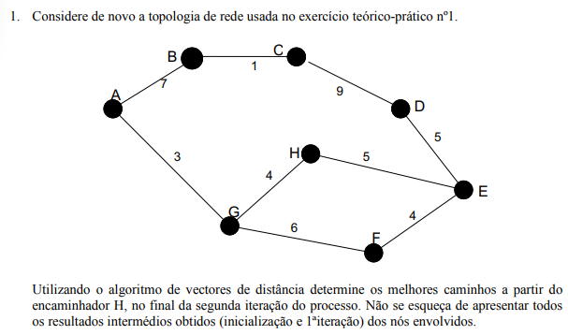

Inicialização 1ª iteração 2ª iteração

|  |  |  |
| --- | --- | --- |
| DA | B | G |
| B | 7 |  |
| C |  |  |
| D |  |  |
| E |  |  |
| F |  |  |
| G |  | 3 |
| H |  |  |

|  |  |  |
| --- | --- | --- |
| DB | A | C |
| A | 7 |  |
| C |  | 1 |
| D |  |  |
| E |  |  |
| F |  |  |
| G |  |  |
| H |  |  |

|  |  |  |
| --- | --- | --- |
| DC | B | D |
| A |  |  |
| B | 1 |  |
| D |  | 9 |
| E |  |  |
| F |  |  |
| G |  |  |
| H |  |  |

|  |  |  |
| --- | --- | --- |
| DD | C | E |
| A |  |  |
| B |  |  |
| C | 9 |  |
| E |  | 5 |
| F |  |  |
| G |  |  |
| H |  |  |

|  |  |  |  |
| --- | --- | --- | --- |
| DE | F | H | D |
| A |  |  |  |
| B |  |  |  |
| C |  |  |  |
| D |  |  | 5 |
| F | 4 |  |  |
| G |  |  |  |
| H |  | 5 |  |

|  |  |  |
| --- | --- | --- |
| DF | E | G |
| A |  |  |
| B |  |  |
| C |  |  |
| D | 4 |  |
| E |  |  |
| G |  | 6 |
| H |  |  |

|  |  |  |  |
| --- | --- | --- | --- |
| DG | H | F | A |
| A |  |  | 3 |
| B |  |  |  |
| C |  |  |  |
| D |  |  |  |
| E |  |  |  |
| F |  | 6 |  |
| H | 4 |  |  |

|  |  |  |
| --- | --- | --- |
| DH | G | E |
| A |  |  |
| B |  |  |
| C |  |  |
| D |  |  |
| E |  | 5 |
| F |  |  |
| G | 4 |  |

|  |  |  |
| --- | --- | --- |
| DH | G | E |
| A | 7 |  |
| B |  |  |
| C |  |  |
| D |  | 10 |
| E |  | 5 |
| F | 10 | 9 |
| G | 4 |  |

|  |  |  |
| --- | --- | --- |
| DH | G | E |
| A | 7 |  |
| B | 14 |  |
| C |  | 19 |
| D |  | 10 |
| E | 14 | 5 |
| F | 10 | 9 |
| G | 4 | 15 |

|  |  |  |  |
| --- | --- | --- | --- |
| DE | F | H | D |
| A |  |  |  |
| B |  |  |  |
| C |  |  | 14 |
| D |  |  | 5 |
| F | 4 |  |  |
| G | 10 | 9 |  |
| H |  | 5 |  |

|  |  |  |  |
| --- | --- | --- | --- |
| DE | F | H | D |
| A | 13 | 12 |  |
| B |  |  | 15 |
| C |  |  | 14 |
| D |  |  | 5 |
| F | 4 | 15 |  |
| G | 10 | 9 |  |
| H | 14 | 5 |  |

|  |  |  |  |
| --- | --- | --- | --- |
| DG | H | F | A |
| A |  |  | 3 |
| B |  |  | 10 |
| C |  |  |  |
| D |  |  |  |
| E | 9 | 10 |  |
| F |  | 6 |  |
| H | 4 |  |  |

|  |  |  |  |
| --- | --- | --- | --- |
| DG | H | F | A |
| A |  |  | 3 |
| B |  |  | 10 |
| C |  |  | 11 |
| D | 14 | 15 |  |
| E | 9 | 10 |  |
| F | 13 | 6 |  |
| H | 4 | 15 |  |

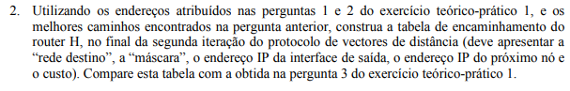

|  |  |  |  |
| --- | --- | --- | --- |
| REDE DE DESTINO | INTERFACE DE SAÍDA | PRÓXIMO NÓ | CUSTO |
| A | 192.168.0.34 | 192.168.0.30 | 7 |
| B | 192.168.0.34 | 192.168.0.30 | 14 |
| C | 192.168.0.33 | 192.168.0.21 | 19 |
| D | 192.168.0.33 | 192.168.0.14 | 10 |
| E | 192.168.0.33 | 192.168.0.21 | 5 |
| F | 192.168.0.33 | 192.168.0.22 | 9 |
| G | 192.168.0.34 | 192.168.0.30 | 4 |



|  |  |  |
| --- | --- | --- |
| DB | A | C |
| A | 7 |  |
| C |  | 1 |
| D |  |  |
| E |  |  |
| F |  |  |
| G |  |  |
| H |  |  |

|  |  |  |
| --- | --- | --- |
| DB | A | C |
| A | 7 | 9 |
| C | 9 | 1 |
| D |  | 10 |
| E |  |  |
| F |  |  |
| G | 10 |  |
| H |  |  |

|  |  |  |
| --- | --- | --- |
| DB | A | C |
| A | 7 | 9 |
| C | 9 | 1 |
| D | 24 | 10 |
| E | 29 | 15 |
| F | 16 | 18 |
| G | 10 | 12 |
| H | 14 | 16 |

|  |  |  |
| --- | --- | --- |
| DC | B | D |
| A |  |  |
| B | 1 |  |
| D |  | 9 |
| E |  |  |
| F |  |  |
| G |  |  |
| H |  |  |

|  |  |
| --- | --- |
| DB | C |
| A | ∞ |
| C | 1 |
| D | 10 |
| E | 15 |
| F | 18 |
| G | 12 |
| H | 16 |

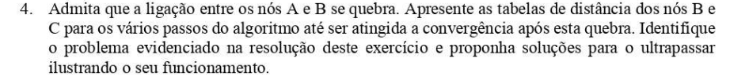

Inicialização 1ª iteração 2ª iteração 3ª iteração 4ª iteração 5ª iteração

|  |  |
| --- | --- |
| DB | C |
| A | ∞ |
| C | 1 |
| D | ∞ |
| E | ∞ |
| F | ∞ |
| G | ∞ |
| H | ∞ |

|  |  |
| --- | --- |
| DB | C |
| A | ∞ |
| C | 1 |
| D | 10 |
| E | ∞ |
| F | ∞ |
| G | ∞ |
| H | ∞ |

|  |  |
| --- | --- |
| DB | C |
| A | ∞ |
| C | 1 |
| D | 10 |
| E | 15 |
| F | ∞ |
| G | ∞ |
| H | ∞ |

|  |  |
| --- | --- |
| DB | C |
| A | ∞ |
| C | 1 |
| D | 10 |
| E | 15 |
| F | 19 |
| G | ∞ |
| H | 20 |

|  |  |
| --- | --- |
| DB | C |
| A | ∞ |
| C | 1 |
| D | 10 |
| E | 15 |
| F | 19 |
| G | 24 |
| H | 20 |

|  |  |
| --- | --- |
| DB | C |
| A | 27 |
| C | 1 |
| D | 10 |
| E | 15 |
| F | 19 |
| G | 24 |
| H | 20 |

|  |  |  |
| --- | --- | --- |
| DC | B | D |
| A | ∞ | ∞ |
| B | 1 | 10 |
| D | ∞ | 9 |
| E | ∞ | 14 |
| F | ∞ | ∞ |
| G | ∞ | ∞ |
| H | ∞ | ∞ |

|  |  |  |
| --- | --- | --- |
| DC | B | D |
| A | ∞ | ∞ |
| B | 1 | 10 |
| D | ∞ | 9 |
| E | ∞ | 14 |
| F | ∞ | ∞ |
| G | ∞ | ∞ |
| H | ∞ | ∞ |

|  |  |  |
| --- | --- | --- |
| DC | B | D |
| A | ∞ | ∞ |
| B | 1 | 10 |
| D | ∞ | 9 |
| E | ∞ | 14 |
| F | ∞ | 18 |
| G | ∞ | ∞ |
| H | ∞ | 19 |

|  |  |  |
| --- | --- | --- |
| DC | B | D |
| A | ∞ | ∞ |
| B | 1 | 10 |
| D | ∞ | 9 |
| E | ∞ | 14 |
| F | ∞ | 18 |
| G | ∞ | 23 |
| H | ∞ | 19 |

|  |  |  |
| --- | --- | --- |
| DC | B | D |
| A | ∞ | 26 |
| B | 1 | 10 |
| D | ∞ | 9 |
| E | ∞ | 14 |
| F | ∞ | 18 |
| G | ∞ | 23 |
| H | ∞ | 19 |